**Isomo Academy Student Transcript**

Bridge2Rwanda

KK 737 St, Kigali, Rwanda

**Student Name**: Ineza Gabin Rwigema

**Date**: 09/22/2023

|  |  |
| --- | --- |
| **Year 1: Isomo Foundation Year | 2022** | **Grade** |
| Guided Reading | PASS |
| Communication Arts | PASS |
| Academic Writing | PASS |
| Language Lab | PASS |
| Innovation and Leadership | PASS |
| Mental Health Hour | PASS |
| Spiritual Formation | PASS |

|  |  |
| --- | --- |
| **Year 2: Isomo University | 2023** | **Grade** |
| Philosophy: A Brief History of Ideas | A- |
| Research Capstone | A- |
| Climate Economy | A |
| African Literature | A |
| Innovative Leadership + Model Umushyikirano | A |
| Worldviews: A Survey of Global Perspectives | A |
| Experiencing Jesus | A |

**Grade Point Average:** 3.91

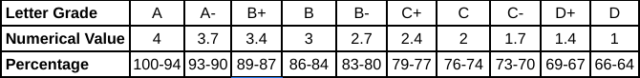

**Advisor**:

Luke Dreiling, Lead Teacher